TERRANEXT GLOBAL VENTURES
AI Intelligence Platform
Operations Manual
Document 7 of 8 · Version 1.0
August 2, 2026
CONFIDENTIAL — Prepared exclusively for TerraNext Global Ventures

Document Control
Document Title | AI Intelligence Platform — Operations Manual
System | TerraNext Business OS
Classification | Confidential — Client Delivery
Prepared For | TerraNext Global Ventures
Prepared By | Engineering Documentation Team
Status | Final
Related Documents | Administrator Guide; User Guide; Installation & Deployment Guide

Version History
Version | Date | Author | Description of Changes
1.0 | 2026-08-02 | Engineering Documentation Team | Initial release — converted from the Markdown source of truth for client handover.

Table of Contents
Right-click this table and choose "Update Field" → "Update entire table" to populate page numbers after opening this document in Word.

ℹ NOTE
This manual covers routine operation and incident response. For one-time setup and configuration, see the Administrator Guide. For deployment and technical configuration, see the Installation & Deployment Guide.

1. Purpose & Scope
This manual describes the routine tasks needed to keep the AI Intelligence Platform running smoothly once it has been configured, and the steps to follow when something goes wrong. It is written for the person who checks on the platform day to day — confirming sessions are processing normally, clearing failed jobs, and knowing who to escalate to when an issue is outside what can be fixed from the CRM interface.

2. Daily Operational Checklist
A brief daily check takes under five minutes:
- Open Dashboard. Confirm Pending processing is not unexpectedly high (a large, growing number suggests a stuck queue — see §4).
- Open Processing Queue. Confirm there are no jobs sitting in Failed for longer than expected.
- Open Settings. Confirm the Active speech provider and Active summary provider badges show the expected provider (not the demonstration/mock mode) if real AI processing has been configured for your organization.
✔ BEST PRACTICE
Do this check at the same time each day (for example, at the start of the working day) so a stuck queue is caught before a trainer or coordinator notices it first.

3. Monitoring the Platform
Three screens double as monitoring surfaces:
Screen | What to watch
Dashboard | Today's sessions, pending processing count, completed count, recording hours — a sudden drop in completions or a rising "pending" count is the earliest visible sign of a problem
Processing Queue | Any job sitting at a non-terminal stage (Queued, Transcribing, Merging transcript, AI analysis, Saving) for an unusually long time, or any job in Failed
Analytics | The daily "sessions failed" total — a spike on a given day points to that day's provider or connectivity issue
ℹ NOTE
Longer recordings naturally take longer to process, since each segment of a session is transcribed in turn rather than all at once. A 90-minute session taking noticeably longer than a 15-minute one is expected behavior, not a fault.

4. Incident Response Procedures
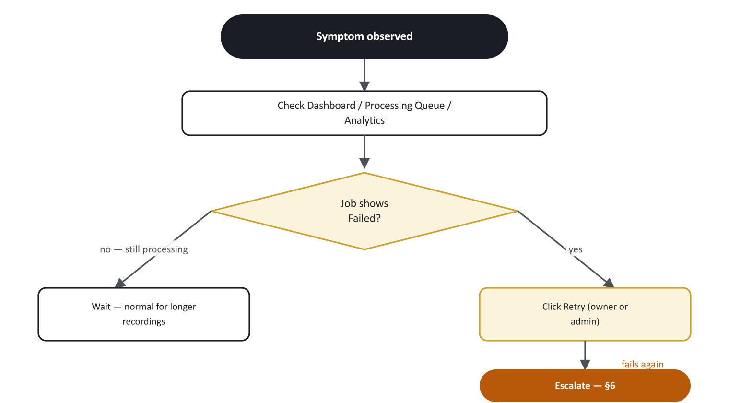
Figure 1. Incident response decision flow.
Symptom | Likely cause | Response
Several sessions stuck on Processing at once | A provider outage, or a burst of sessions finishing at the same time creating a backlog | Wait a short period for the backlog to clear; if jobs start showing Failed with the same error message, treat as a provider outage — escalate to your technical team (§6)
A single job shows Failed | The AI transcription or analysis step hit an error for that session only | Click Retry (System Administrators and Founders can retry any job) — it resumes rather than restarting from scratch. If it fails again with the same error, escalate
Every new session completes with placeholder-looking transcript/summary text | AI processing has silently reverted to demonstration mode, most likely because a provider credential expired or was misconfigured | Escalate to your technical team immediately — this does not stop sessions from "completing," so it can go unnoticed without the daily check in §2
A trainer reports a recording that never finished saving | The browser tab was closed or crashed before the last segment finished uploading | Do not ask the trainer to delete and re-record over the same session. Escalate to your technical team — the segments that did upload successfully are still safely stored and may be recoverable
A trainer cannot see the Retry button on their own failed job | Working as intended — only the session's owner or a System Administrator/Founder can retry a job | If the original trainer is unavailable, a System Administrator or Founder retries on their behalf
A user reports "not authorized" on any AI Intelligence Platform page | Their role does not include the required access | Confirm their role assignment; adjust if the access should be granted
⚠ WARNING
Never remove (soft-delete) a session as a way to "clear" a stuck or failed one — deletion hides it from the active list but does not restart, retry, or fix processing. Use the Retry action for failed jobs instead.

5. Routine Maintenance Tasks
- Weekly: review the Processing Queue for any long-failed jobs that were never retried, and either retry or investigate them.
- Weekly: spot-check the Analytics screen's "sessions failed" trend — a rising trend over several days (rather than an isolated spike) is worth escalating even if each individual failure was retried successfully.
- As needed: remove (soft-delete) sessions that are no longer relevant to the active list, per the Administrator Guide §3. This does not delete the underlying recording, transcript, or summary.
- Periodically: confirm with your technical team what audio retention and completion-notification behavior is currently active for your deployment, since the values on the Settings screen record your organization's intended policy but their enforcement should be periodically reconfirmed with the technical team (see Administrator Guide §4).

6. Escalation Path
Issue type | Escalate to
Access/role/permission questions | Your organization's System Administrator
A single job repeatedly failing with the same error | Your technical/engineering team, with the exact error message from the Processing Queue row
Provider badge shows demonstration mode unexpectedly | Your technical/engineering team — this is a configuration issue, not something fixable from the CRM
A session's recording did not finish saving | Your technical/engineering team — do not delete or re-record the session first
Broader platform outage (nothing loads, every session fails) | Your technical/engineering team, treated as a priority incident
When escalating, always include: the session title and/or ID (visible in the page URL), the exact status/stage shown, and the exact error text if one is displayed.

7. Backup & Retention Notes
- Removing (soft-deleting) a session from the Sessions list does not delete its recording, transcript, or summary — it only hides it from the active list.
- The Settings screen's audio retention value records your organization's intended retention policy. Confirm with your technical team what enforcement is currently active before relying on it for a compliance requirement.
- The organization's audit log records every session creation, recording-finalization, removal, settings change, and job retry, each with who performed it and when — useful for answering "who did what" during an incident review.

8. Appendix — Status & Stage Reference

Session status
Status | Meaning
Draft | Session created, recording hasn't started
Recording | Actively capturing audio
Processing | Recording finished; transcription and AI analysis running
Completed | Transcript and summary are ready
Failed | Processing hit an error

Processing stage
Stage | Meaning
Queued | Waiting to begin
Transcribing | Converting the recording to text, segment by segment
Merging transcript | Combining all segments into one session transcript
AI analysis | Generating the executive summary, key points, questions, and action items
Saving | Writing the final results
Completed | Finished
Failed | An error occurred

